West Moors Middle School – Y6 Curriculum Map
Area of learning | Termly Overview
 | Autumn | Spring | Summer
English (7h)  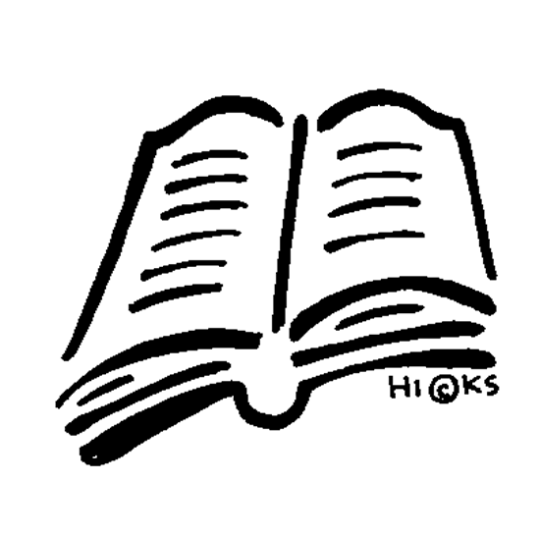 | Booster  Mystery Writing  Guided Reading: Pig Heart Boy, Wonder & Silver Sword | Journalistic Writing Biography  Discursive Writing  Guided Reading: Pig Heart Boy, Wonder & Silver Sword | Letters of Complaint  Non-chronological Reports  Kensuke’s Kingdom  Poetry by Heart  Guided Reading: Pig Heart Boy, Wonder & Silver Sword
Maths (6h)  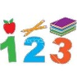 | Place value  Four operations  Order of operation | Fractions and percentages  Shape, space and measure  Angles  Mean and Ratio | Problem Solving  Geometrical construction
Physical Education (2h) | Basketball  Tag Rugby  Badminton  Football | Gymnastics  Indoor Hockey/Indoor Athletics  Netball  Cricket/Rounders | Cricket/Rounders  Athletics  Tennis
PSHE  (1h) | Being Me in My World  Celebrating Difference | Dreams and Goals  Healthy Me | Relationships  Changing Me
Cross-Curricular Learning | Venturesome Vikings | Mighty Mountains | Titanic Tragedy
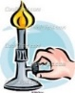  Science (2h) | Forces  Evolution  Changing states | Electricity  Classification | Growth and development
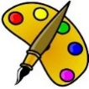  Art (1h) | Exploring Viking art  Create a Viking inspired warrior helmet | Mountain Landscapes – German landscapes | Water project – Painting and collage
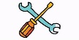  DT (1h) | Vikings | Model village | Textiles - teddy
Computing (1h) | Networks and Databases | Programming | Media
Humanities (1h)  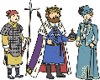  History | Vikings | The History of Mountains | Titanic Tragedy
Humanities (1h)  Geography | Scandinavia | Mountains | Titanic
Humanities (1h)  RE | Christianity | Christianity | Christianity
Spanish (1h) | Family & Pets  Personality & descriptions | Hobbies & opinions  Food & Drink | Body & Health
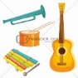  Music  (1h) | Magic Hands  Mood Food  We Will Remember Them  Christmas Crackers | The Lost Planet  Milonga Momentos | Mountain Kings and River Queens  My Heart Will Go On  Whole School Production

