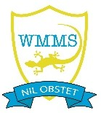
West Moors Middle School Remote Learning 2022-2023

If your child is not ill but has to isolate, they must continue with their learning from home.

Whilst your child is learning remotely, they should follow their usual structured timetable every day, accessing the Courses for each of their subjects on the Its Learning Platform, and returning their work every lesson through Its Learning for feedback from their teachers.
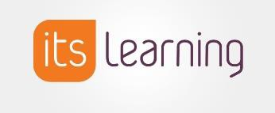

In their Computing lessons, pupils have been taught how to use the Its Learning Platform effectively and their passwords have been recorded in Homework Planners. Once pupils log in to this platform, it is very straightforward to navigate and they can access all their lessons and learning resources required for each lesson easily. When pupils do occasionally experience problems logging in, it generally tends to be if they have changed their password and subsequently forgotten it, but we can always reset these if necessary.

Pupil’s responsibility
Each pupil is responsible for managing their remote learning and should:
- Have use of a device on which to access Its Learning (e.g. computer / laptop/ tablet / smartphone)
- Work on Its Learning from 8:50am – 3.25pm, taking their normal morning and lunchtime breaks
- Follow their usual timetable
- Return their work to their class teachers through the assignment box for each lesson

During any period of Remote Learning, it is essential that all children are provided with a safe online environment with age-appropriate, parental controls set on digital devices and internet filters to block malicious websites where possible. These are usually free, but often need to be turned on.
The following resources can be used to support keeping children safe online:
- support for parents and carers to keep children safe online, which outlines resources to help keep children safe from different risks online and where to go to find support and advice
- guidance on staying safe online which includes information on security and privacy settings
- Thinkuknow provides advice from the National Crime Agency (NCA) on staying safe online
- Parent info is a collaboration between Parentzone and the NCA providing support and guidance for parents from leading experts and organisations
- Childnet offers a toolkit to support parents and carers of children of any age to start discussions about their online life, to set boundaries around online behaviour and technology use, and to find out where to get more help and support

For help with remote learning, contact us on 01202 872474 or email: office@westmoorsmid.dorset.sch.uk

