West Moors Middle School – Y6 Curriculum Map
Area of learning | Termly Overview
Area of learning | Autumn | Spring | Summer
English (7h)  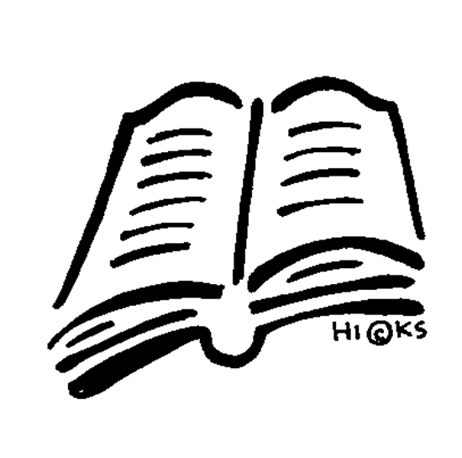 | Booster  Mystery Writing  Guided Reading: Holes | Mystery Writing  Journalistic Writing Biography  Discursive Writing  Guided Reading: Holes & The Boy at the Back of the Class | Letters of Complaint  Non-chronological Reports  Kensuke’s Kingdom  Poetry by Heart  Guided Reading: The Boy at the Back of the Class
Maths (6h)  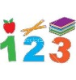  Maths No Problem!  Curriculum | 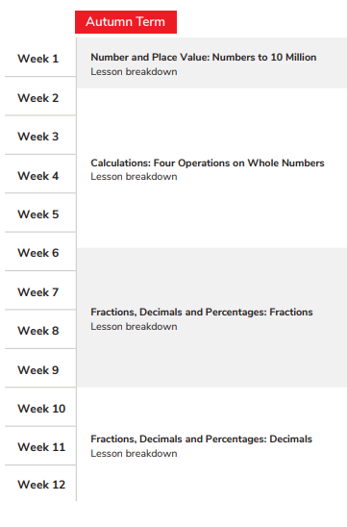 | 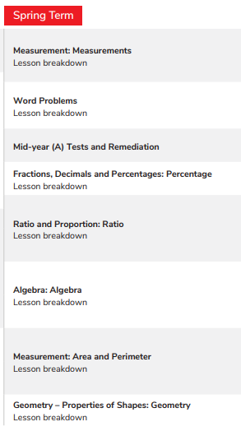 | 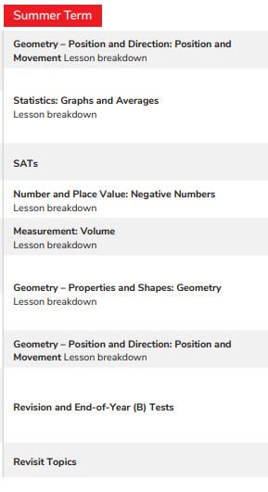
Physical Education (2h)   | Basketball  Tag Rugby  Badminton  Football | Gymnastics  Indoor Hockey/Indoor Athletics  Netball  Cricket/Rounders | Cricket/Rounders  Athletics  Tennis
  PSHE  (1h) | Being Me in My World  Celebrating Difference | Dreams and Goals  Healthy Me | Relationships  Changing Me
Cross-Curricular Learning | Venturesome Vikings | Mighty Mountains | Titanic Tragedy
  Science (2h) | Evolution  Forces  Changing states | Electricity  Classification | Growth and development
  Art (1h) | Portraits | Yayoi Kusama patterns | Outer space
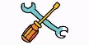  DT (1h) | Scrap robots | Healthy soups | Finger knitting
  Computing (1h) | Search Engines & Spreadsheets | Programming & Flow Charts | Web Designing & 3D Modelling
Humanities (1h)  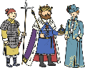  History | Vikings | The History of Mountains | Titanic Tragedy
Humanities (1h)  Geography   | Scandinavia | Mountains | Titanic
Humanities (1h)    RE | Christianity | Christianity | Christianity
  Spanish (1h) | Introducing Spain  Introduce myself. | Countries, nationalities  Family | Cafeteria
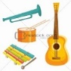  Music  (1h) | Folk Music  Pentatonic Composition | Video Game Composition | Performing Pop Music

