West Moors Middle School – Y5 Curriculum Map
Area of learning | Termly Overview
Area of learning | Autumn | Spring | Summer
English (7h)  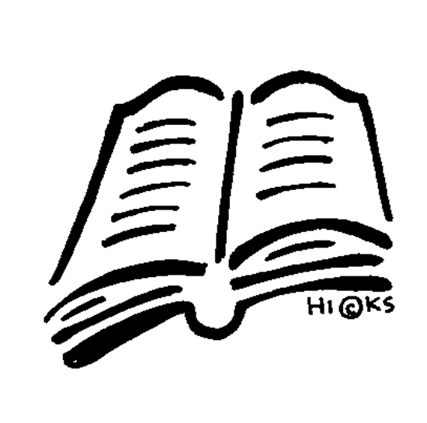 | SPAG booster  Talk 4 Writing  - Recount (Diary) Writing  - Explanation Writing  - Adventure Story  - Non-Chronological Reports  Reading: Friend or Foe by Michael Morpurgo | Talk 4 Writing  - Play Script  - Discussion Writing  - Finding Story  - Persuasive Writing  Reading: Oranges in No Man’s Land by Elizabeth Laird | Talk 4 Writing  - Wishing Story  - Narrative Poetry  - Portal Story  - Flashback Story  Reading: Tales of the Family from One End Street by Eve Garnett
Maths (6h)  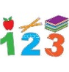  Maths No Problem!  Curriculum | 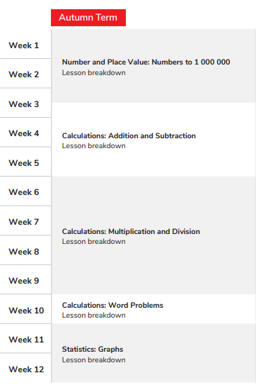 | 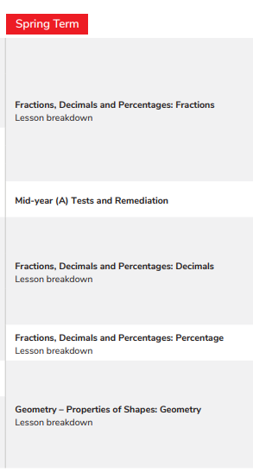 | 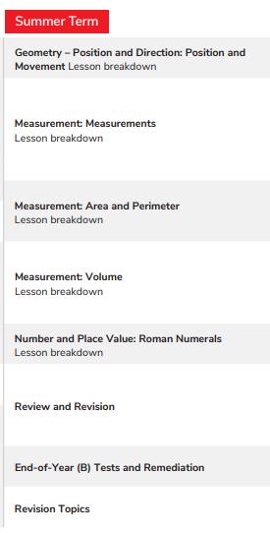
  PE (2h) | Basketball  Tag Rugby  Badminton  Football | Gymnastics  Indoor Hockey  Netball  Cricket/Rounders | Cricket/Rounders  Swimming  Athletics  Tennis
  PSHE  (1h) | Being Me in My World  Celebrating Difference | Dreams and Goals  Healthy Me | Relationships  Changing Me
Cross-Curricular Learning | Amazing Africa | Captivating China | Brilliant Britain
  Science (2h) | Keeping Healthy  Space | Light  Materials and Properties | Life Cycles
  Art (1h) | A world of colour | Insects | Natural forms
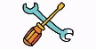  DT (1h) | Woodwork | Healthy me | Textiles  Scrap collages
  Computing (1h) | Networks and Databases | Algorithms & Quizzes | Photo manipulation & Videos
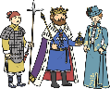  History (1h) | The Kingdom of Benin | The Shang Dynasty | Rebuilding Britain
  Geography  (1h) | Exploring Africa | What is China like? | The United Kingdom
  RE (1h) | Buddhism | Judaism | Christianity
Spanish (1h)   | Introducing Spain  Say my name. Numbers. Colours | Animals  Shapes | Fruit  Months of the year/days of the week
  Music  (1h) | Ukulele skills and singing | World Tour | Animation Composition

